## **A Web-Based Meditation Timer**

### **Enhancing Mindfulness Through Technology**

**Date :- 13th May 2025**

**Team Name :- Code Warriors**

**Team Lead**

Aathira V Sajive

Vrushali Mujumdar

**Developers**

Prasad Gujarathi

Vaishnavi Dhobale

Pooja Kothawade

**Cloud Engineers**

Abhishek Choudhary

Gaurav Chaudhari

Aadheesh Phade

**Documentation**

Pramod Patil (Developer)

Prajakta Wanjari (Developer)

Parth Satish (Cloud Engineer)

Application Link: <http://codewarriorshackathon.s3-website.ap-south-1.amazonaws.com/>

GitHub Link: <https://github.com/VaishnaviDhobale/Code-Warriors>

**Project Overview**

The Mindfulness Timer is a web application designed to help users practice mindfulness and meditation through timed sessions. Users can choose predefined time durations and receive a gentle bell sound when the timer ends. This app aims to promote mental well-being and encourage brief, meaningful breaks.

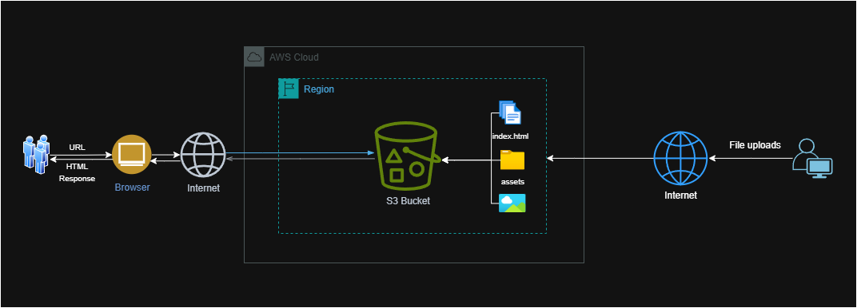

**Tech Stack**

Frontend: HTML, CSS, JavaScript

Cloud Hosting: AWS S3 (Static Website Hosting)

Tools: Visual Studio Code, GitHub, AWS Management Console

**Hosting & Deployment**

The project is deployed using Amazon S3 static website hosting.

All static assets are served directly from S3.

Permissions and policies were configured to allow secure public access.

### **Implementation Details**

* JavaScript’s setTimeout() and setInterval() for timing logic
* LocalStorage for saving preference

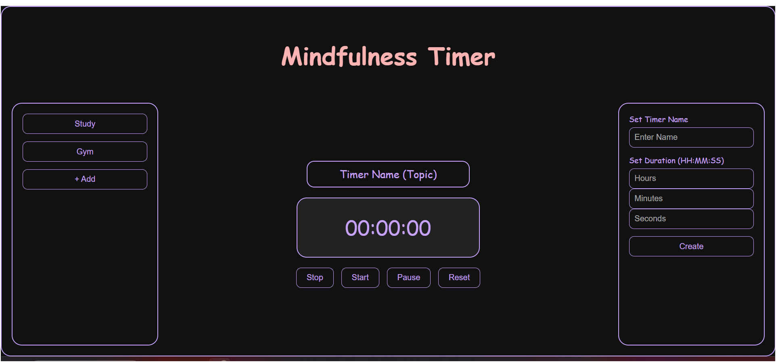

**Coding documentation**

Index.html file

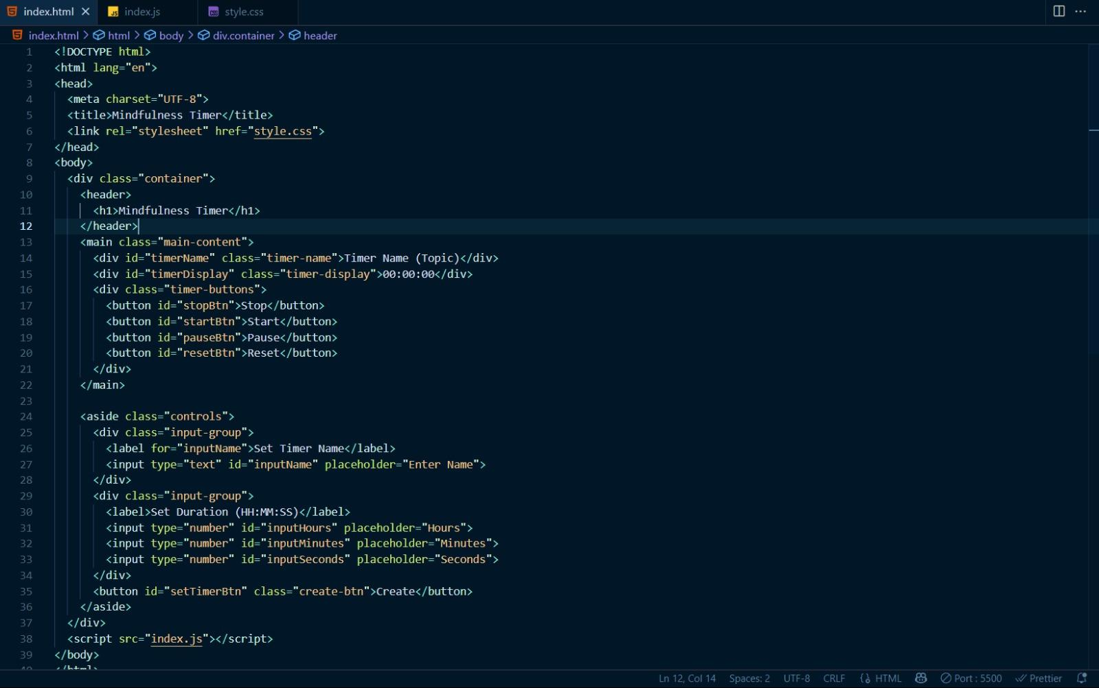

## Javascript files

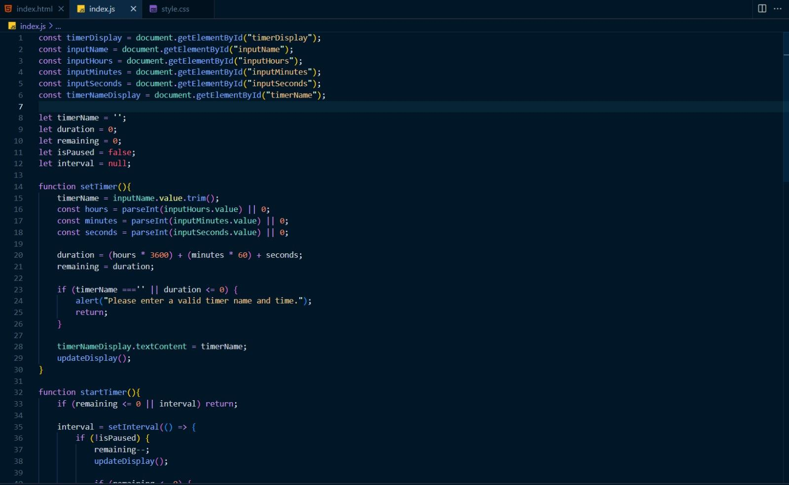

## Stylesheet(CSS) Files

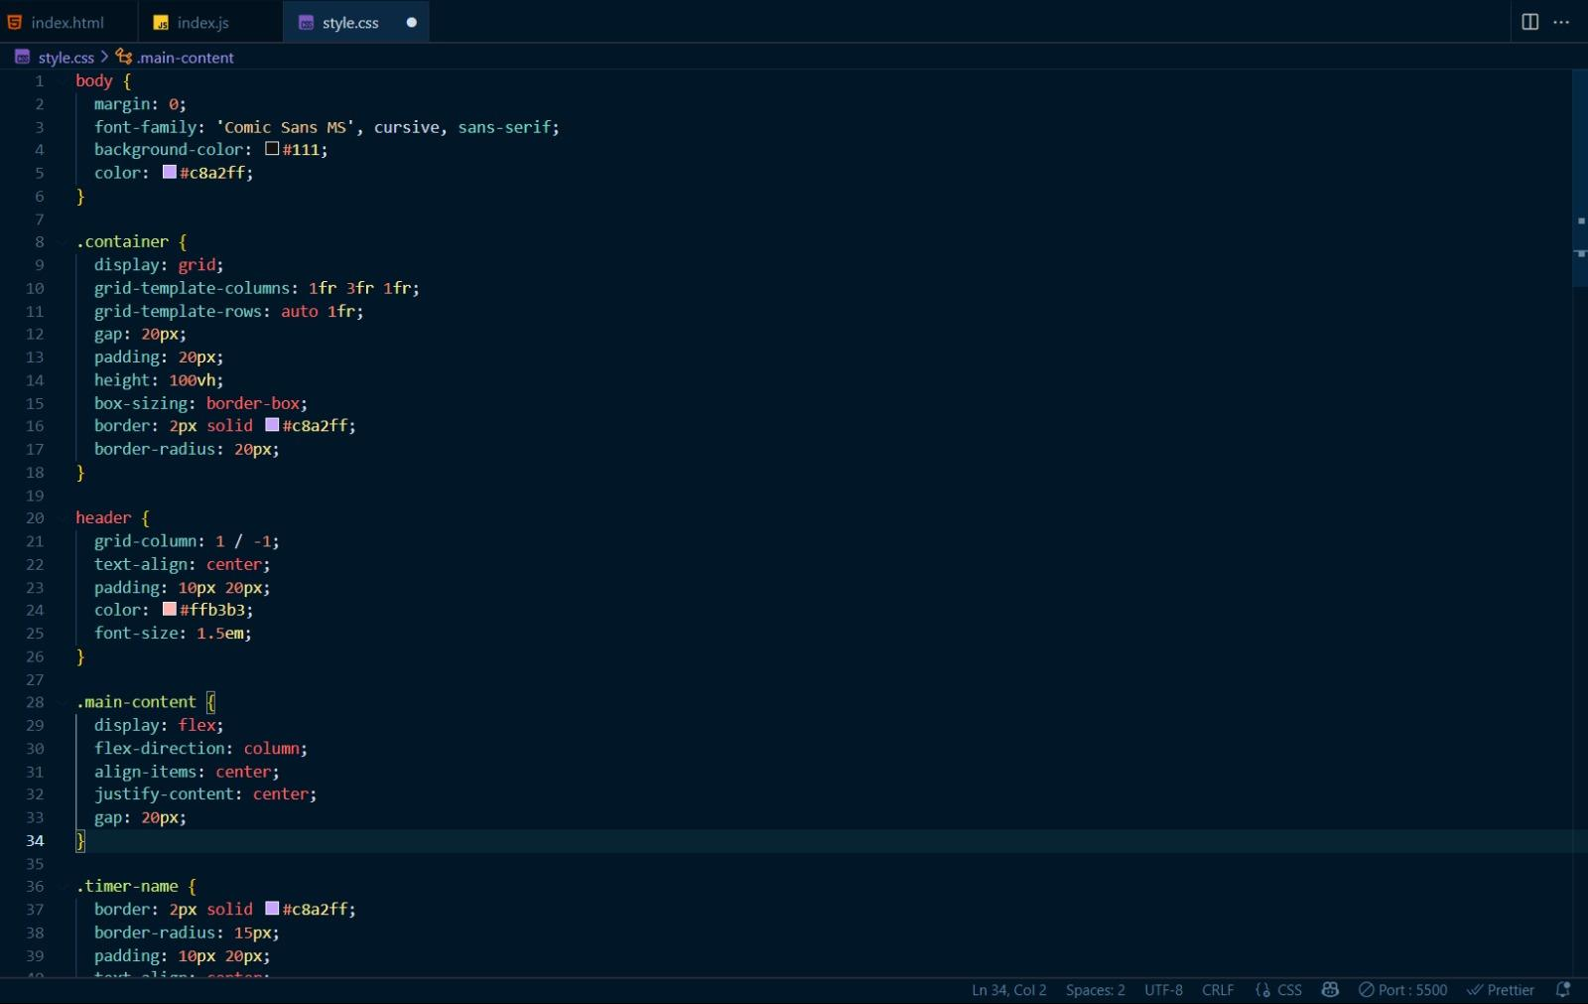

**Set Up AWS Environment**

**Step 1: Creating an S3 bucket in AWS Console.**

* Go to Aws Console
* Search for S3
* Create New S3 Bucket
* Select the Bucket type As General purpose.
* Unmark the Block Public Access Settings for this Bucket so that Everyone can access from the URL.
* Now Click on Create Bucket.
* The new Bucket is Now Available.

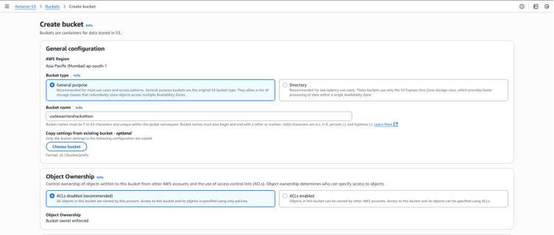

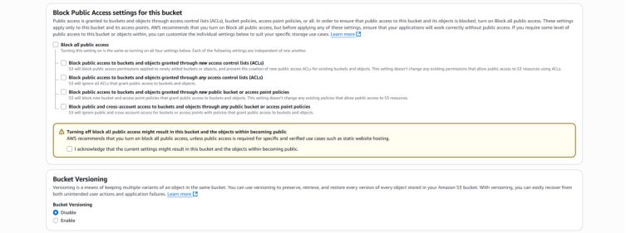

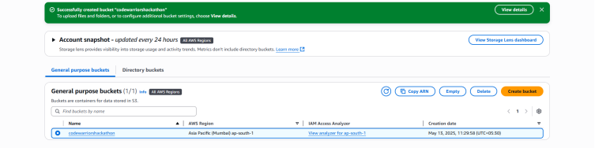

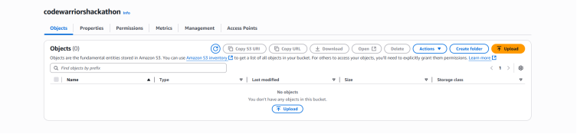

**Step 2: Add Policy**

An S3 bucket policy in AWS is a resource-based policy that grants access permissions to your S3 bucket and the Object within it is the JSON document that defines permission for accessing a specific bucket.

* Click on Edit Bucket Policy
* Click on Policy Generator.
* Select the Type as S3 Bucket Policy.
* In Add Statement Allow the Effect and Enter * in principal
* Enter the ARN which is available in bucket details.

The policy will be generated. Copy the policy and paste it.

**Step 3: Public Block Access disable**

If the Block Public Access bucket setting is ON By default, then turn it to OFF , so that it will Not Block Any Access Request

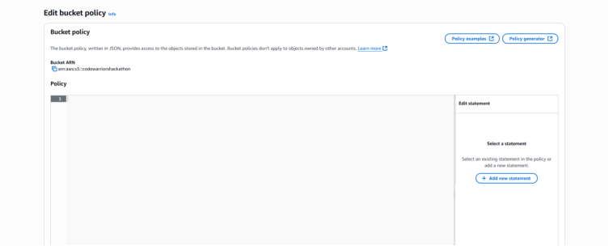

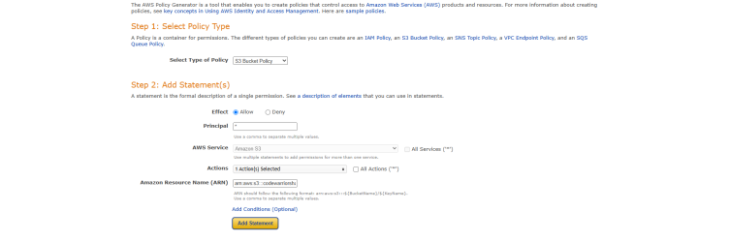

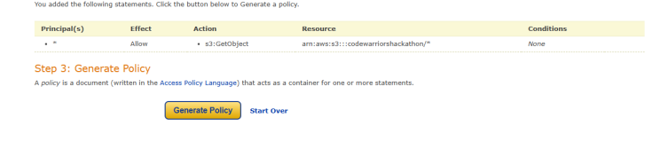

**For Improvement**

While the some functionality was successfully implemented, the following areas are identified for future improvement:

1. Add Persistent Data Storage

Currently, no user data is saved (e.g., timer history or preferences).

Future versions can integrate a database (like AWS DynamoDB).

2. Save custom timers

Track daily meditation/study logs

Personalize user experience

3. Deployment Upgrades

Add CDN (via CloudFront) for faster global access

Enable HTTPS using AWS Certificate Manager and custom domain via Route 53

Note: Delete the resources once you are done with the project.

THANK YOU